Tick[√] the correct question for each answer. Sometimes both are correct.
1 √ What’s your new job like? It’s great.
__ How’s your new job?
2 __ What’s Edinburgh like? It’s a beautiful city with a castle.
__ How’s Edinburgh?
3 __ What was John like? Great. He looked much better.
__ How was John?
4 __ What was your meal like? Fantastic. The best fish I’ve ever had.
__ Do you like this meal?
5 __ What do you feel like? Not so good, actually.
__ How do you feel?
6 __ How old is he? He is 40.
___ How is he?
7 ___How is this room like? About 82 square metres.
___ How big is this room?
8 ___ What does Ann wear? Quite smart. She is not keen on informal clothes.
___ What kind of clothes does Ann wear?
___ What does Ann look like?
9. ___What is this laptop made of? Japan
___Where is this laptop from?
10 ___ What sort of pasta would you like? I’d like some cereal pasta, please.
___ Do you like cereal pasta?
___What’s this pasta like?
11. ___ What do I look like? I am a bit like my mum.
___ Who do I take after?
___What do you like doing?

Doplň: size, does, many, far…
- What ………….boots do you wear. 37
- How ………….. cars have you got? 2. Mercedes and Audi
- How …………. is your house from the school? A ten-minute walk.
- How much …………. is weight? 1 kilo.

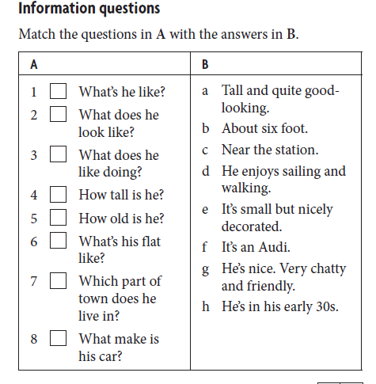

Choose the correct words.

Example
I thought his latest book was quite disappointed / disappointing .

1 I do yoga every day. It makes me very relaxing / relaxed.
2 It’s been raining heavily / badly all day.
3 I enjoy cycling but I find it very tired / tiring.
4 She’s only four but she can read very well / good.
5 I never eat fast / quick food.
6 What went wrongly / wrong with the recipe?
7 You’ll need to work hardly / hard in the weeks before your exams.
8 I bought some lovely home-made / hand-made jewellery in Mexico.
9 I’m feeling exhausted/exhausting. This test was very difficult.
10. She is relaxing/relaxed because the massage was relaxing/relaxed.
11. I have a charming/charmed classmate.
12. My sister is interesting/interested in reading books.
13. This movie was disappointed/disappointing.

Adjectives
- My kids are ..........-behaved. They are always so nice.
- Your kids are ..........-behaved. They are always so rude.
- He is so ......... – working. He always works in his garage or in the garden.
- This decoration is ............-made.
- First-................children are more responsible.

Choose the most suitable word:
- Eat a lot of fresh /brand-new /latest fruit.
- In Gelnica we have old-fashioned / ancient /traditional ruins.
- She is tall, blonde and handsome / pretty / nice.

Add -ly if necessary:

- I dress bad___
- Try to explain it clear____
- He sudden___ came.
- He studies hard_____
- Go straight____!
- Walk slow____!
- I almost____ fell.
- Have you finished? Almost____. Give me 5 minutes.
- He drives very fast_____.

Answer key:
Tick: 1.1, 2.1, 3.2, 4.1, 5.2, 6.1, 7.2, 8.2, 9.2, 10.1, 11.2
Doplň: Size, many, far, does
Information questions: 1g, 2a, 3d, 4b, 5h, 6e, 7c, 8f
Adjectives: well, badly, hard, hand, born
Choose the most suitable word: fresh, ancient, pretty
Add -ly if necessary: badly, clearlym suddenly, hard, straight, slowly, almost, almost, fast.

